
Instructions for Completing
an Amber Alert Form

Step 1:
Amber Alert Form: Authorization for Release and General Alert Information Page
The agency reporter will:
- Read the Authorization for Release of Missing Child Information section, then under this section:
  - Fill in the Reporting Party (parent, guardian, family etc.) address.
  - Print the Reporting Party name.
  - Electronically sign the section by typing /s/ in front of the signature.
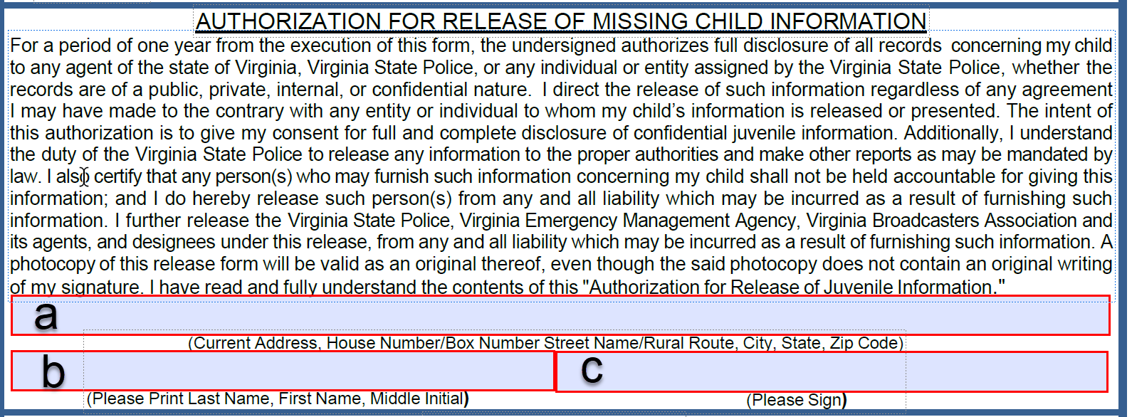
- Read the Liability Agreement section, then under this section:
  - Fill in the Reporting Party (parent, guardian, family etc.) address.
  - Print the Reporting Party name.

  - Electronically sign the section by typing /s/ in front of the signature 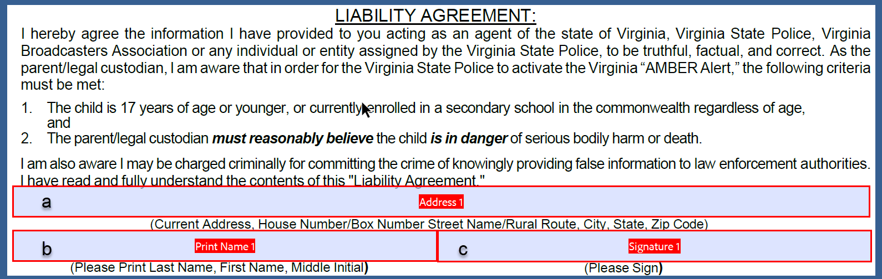
- Fill in the Investigating Agency Contact Information section:
  - Fill in the agency name.
  - Fill in the agency phone number.
  - Fill in the agency fax number.
  - Fill in the reporting officer name.
  - Fill in the reporting officers cell phone number.
  - Fill in the reporting officers email address.
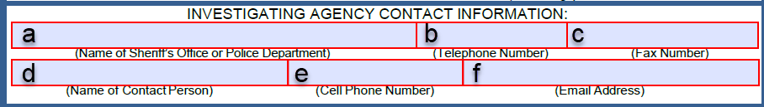
- Fill in the Abduction Information section:
  - Fill in the date of abduction.
  - Fill in the time of abduction.
  - Fill in the vehicle description. (Please provide any vehicle descriptors available)
  - Fill in the location the abduction happened.
  - Fill in the direction of travel and/or where the abductor is heading if known.
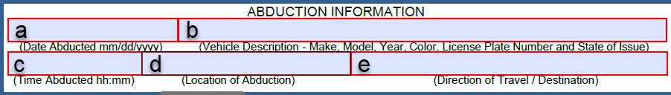
- Fill in the Brief Investigation Description section:
  - In this section, please provide a description of the investigation the major events and relevant information about the events that led to the abduction and any relevant information about the events that followed the abduction. **Please include if the abductor is a known sex offender**

- Enter the date and time the form was submitted to Virginia State Police in the Date and Time Submitted field.
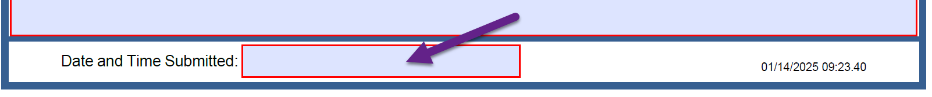

Step 2
Amber Alert Form: Abducted Child Page(s)
The agency reporter will: **Required fields are highlighted in Red**
- 1st Child Information Section
  - Fill in the first missing child’s last name.
  - Fill in the first missing child’s first name.
  - Fill in the first missing child’s middle initial.
  - Select the first missing child’s gender from the dropdown list.
  - Fill in the first missing child’s date of birth (if known) or approximate age.
  - Select the first missing child’s race from the dropdown list.
  - Select the first missing child’s height from the dropdown list.
  - Fill in the first missing child’s weight.
  - Select the first missing child’s hair color from the dropdown list.
  - Select the first missing child’s eye color from the dropdown list.
  - Fill in the first missing child’s shirt description.
  - Fill in the first missing child’s pants description.
  - Fill in the first missing child’s shoe description.
  - Fill in the first missing child’s outerwear description.
  - Fill in the first missing child’s other clothing.
  - Fill in any additional identifiers for the first missing child.
  - Fill in any additional information about the first missing child.
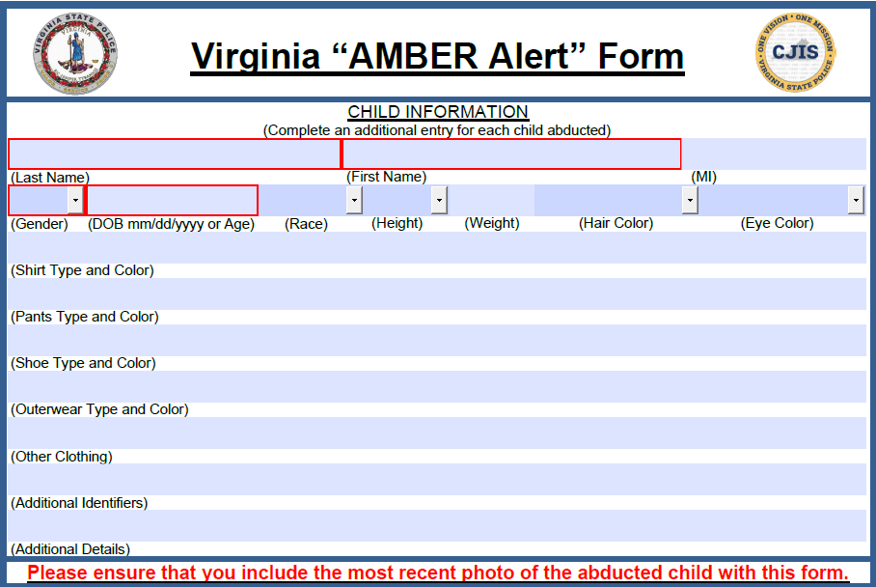
- 2nd Child Information Section, fill out only if you have more than one missing child, if you do not have more than one missing child go to STEP 3. **Required fields are highlighted in Red**
  - Fill in the second missing child’s last name.
  - Fill in the second missing child’s first name.
  - Fill in the second missing child’s middle initial.
  - Select the second missing child’s gender from the dropdown list.
  - Fill in the second missing child’s date of birth (if known) or approximate age.
  - Select the second missing child’s race from the dropdown list.
  - Select the second missing child’s height from the dropdown list.
  - Fill in the second missing child’s weight.
  - Select the second missing child’s hair color from the dropdown list.
  - Select the second missing child’s eye color from the dropdown list.
  - Fill in the second missing child’s shirt description.
  - Fill in the second missing child’s pants description.
  - Fill in the second missing child’s shoe description.
  - Fill in the second missing child’s outerwear description.
  - Fill in the second missing child’s other clothing.
  - Fill in any additional identifiers for the second missing child.
  - Fill in any additional information about the second missing child.
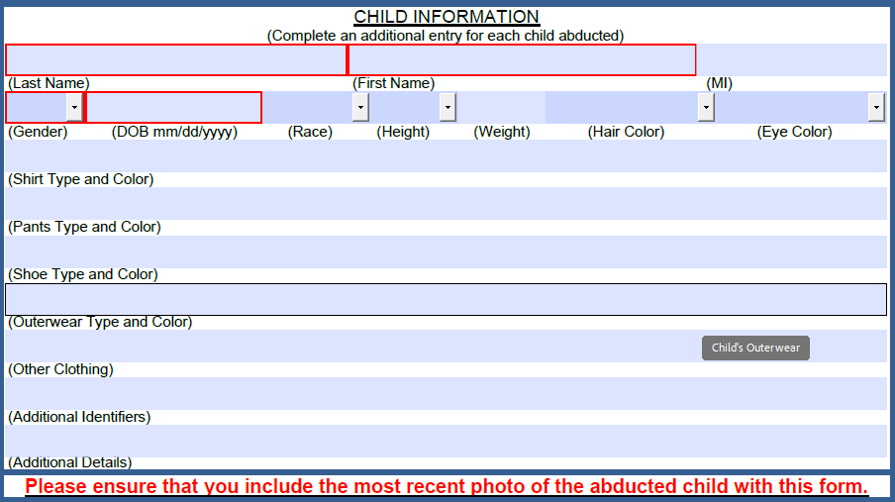
- If you have additional missing children, select the button in the bottom right of the page that says Click to Add Additional Child Page.
If you don’t have any additional missing children go to step 3.
- Repeat 2 & 3 as necessary to add additional missing children. If you have more than 6 missing children, an additional form will be required.
- Once you have completed information for all missing children proceed to STEP 3.
Step 3
Amber Alert Form: Abductor Page(s)
The agency reporter will:
- 1st Abductor Information Section
  - Answer Y(yes) or N(no) to Known Sex Offender
  - Fill in the first abductor’s last name.
  - Fill in the first abductor’s first name.
  - Fill in the first abductor’s middle initial.
  - Select the first abductor’s gender from the dropdown list.
  - Fill in the first abductor’s date of birth (if known) or approximate age.
  - Select the first abductor’s race from the dropdown list.
  - Select the first abductor’s height from the dropdown list.
  - Fill in the first abductor’s weight.
  - Select the first abductor’s hair color from the dropdown list.
  - Select the first abductor’s eye color from the dropdown list.
  - Fill in the first abductor’s shirt description.
  - Fill in the first abductor’s pants description.
  - Fill in the first abductor’s shoe description.
  - Fill in the first abductor’s outerwear description.
  - Fill in the first abductor’s other clothing.
  - Fill in any additional identifiers for the first abductor.
  - Fill in any additional information about the first abductor.
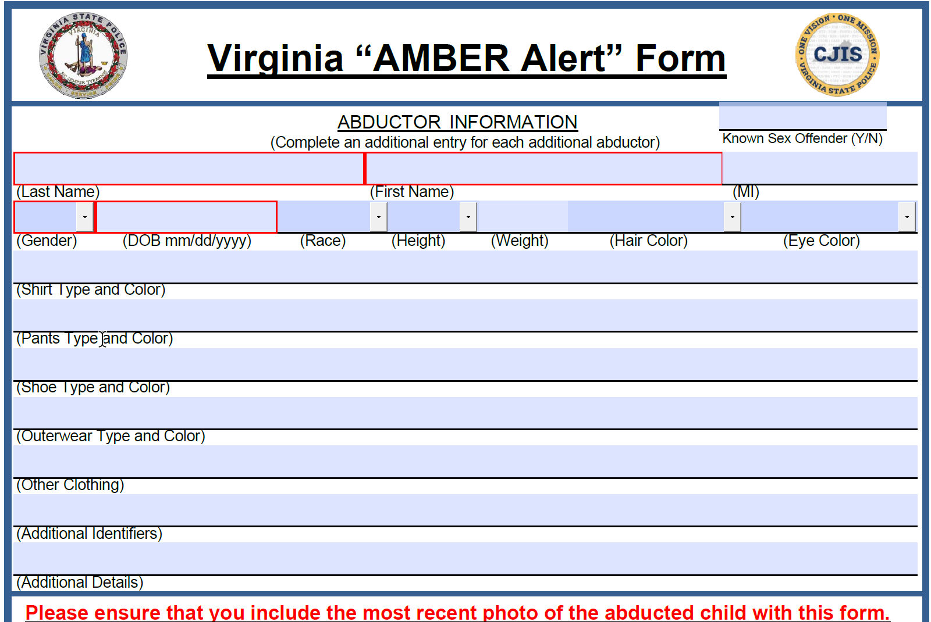
- 2nd Abductor Information Section, fill out only if you have more than one abductor, if you do not have more than one abductor go to STEP 4.
  - Answer Y(yes) or N(no) to Known Sex Offender.
  - Fill in the second abductor’s last name.
  - Fill in the second abductor’s first name.
  - Fill in the second abductor’s middle initial.
  - Select the second abductor’s gender from the dropdown list.
  - Fill in the second abductor’s date of birth (if known) or approximate age.
  - Select the second abductor’s race from the dropdown list.
  - Select the second abductor’s height from the dropdown list.
  - Fill in the second abductor’s weight.
  - Select the second abductor’s hair color from the dropdown list.
  - Select the second abductor’s eye color from the dropdown list.
  - Fill in the second abductor’s shirt description.
  - Fill in the second abductor’s pants description.
  - Fill in the second abductor’s shoe description.
  - Fill in the second abductor’s outerwear description.
  - Fill in the second abductor’s other clothing.
  - Fill in any additional identifiers for the second abductor.
  - Fill in any additional information about the second abductor.

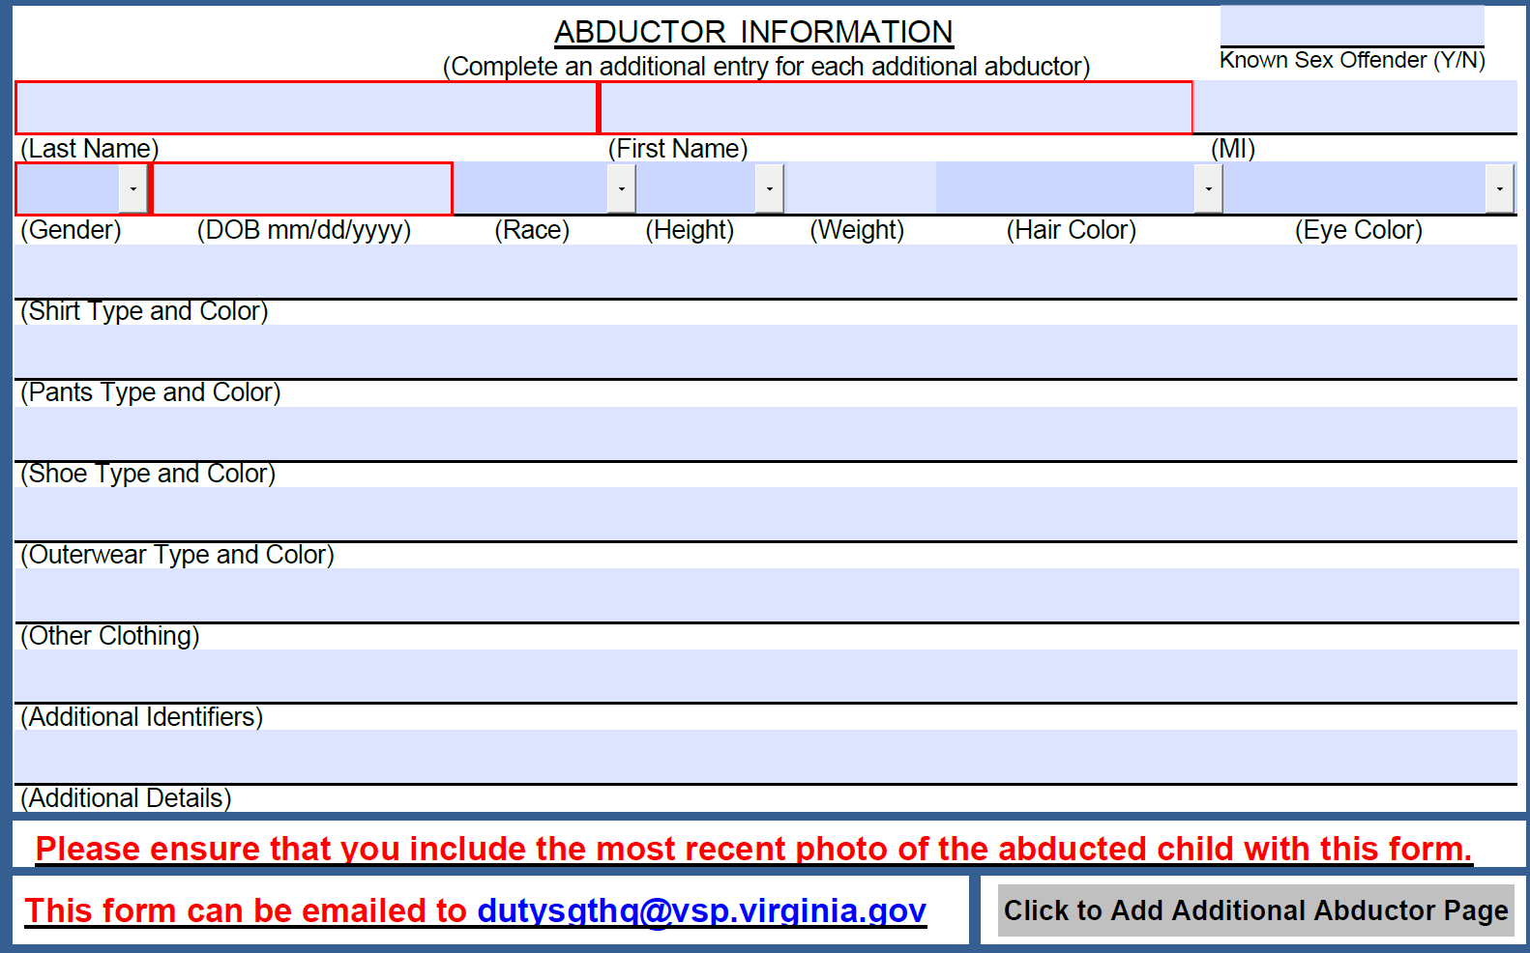
- If you have additional abductors, select the button in the bottom right of the page that says Click to Add Additional Abductor Page.
- If you don’t have any additional abductors go to STEP 4.
- Repeat 2 & 3 as necessary to add additional abductors. If you have more than 6 abductors, an additional form will be required.
- Once you have completed the Abductors Information Sections proceed to STEP 4.

Step 4
Amber Alert Form: Submitting the Amber Alert Form
The agency reporter will:
- Select the save button in the top right.
- Select the save location you wish to save the file to.
- Name the file with the child(ren)’s last name followed by the date of abduction.
** example** Record-01012024 (indicates the child’s last name is Record and was abducted on 01/01/2024)
- Select save.
Scenario 1: Form Emailed to Reporter – In this scenario the form was emailed to the reporting agency, has been completed and will be attached and “replied” back to the original email.
The agency reporter will:
- Return to your email.
- Open the original email in which you received the form.
- Select Reply.
- Select Attach.
- Select the completed Amber Alert Form, the photo(s) of the missing child(ren), and the photo(s) of the abductor(s).
Note: hold down the ctrl key to select multiple files
- Select OK.
- Select Send.
Note: If the email will not send because of the size, send each item individually as a reply.
Scenario 2: Form Obtained from the Virginia State Police Website – In this scenario the form was completed and saved from the VSP Website and is now required to be emailed to VSP for processing.
The agency reporter will:
- Open your email.
- Select New Email.
- In the “To” field enter “dutysgtsphq@vsp.virginia.gov”.
- In the “Subject” line type “Urgent Amber Alert Activation”
- Select Attach.
- Select the completed Amber Alert Form, the photo(s) of the missing child(ren), and the photo(s) of the abductor(s).
Note: hold down the ctrl key to select multiple files
- Select OK.
- In the body of the email, give a brief description of the incident.
- Select Send.
- Please have the investigating officer contact the Duty Sergeant to confirm receipt at (804) 674-2026.
Note: If the email will not send because of the size, send each item individually as a reply.

