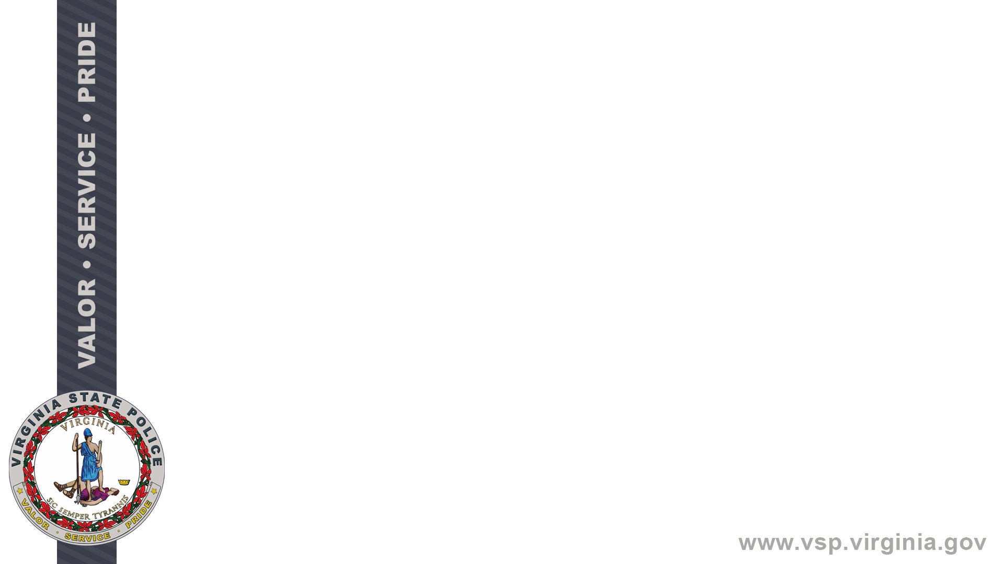




Virginia State Police (VSP)

CCH Seal

Law Enforcement and State Agencies
Seal Notification Services

Interface Control Document

Version 1.0

Table of Contents
DOCUMENT IDENTIFICATION iii
REVISION HISTORY iii
ACRONYMS iii
1. Introduction 2
1.1. Business Purpose 2
1.2. High Level Overview 3
1.3 Account and Billing Setup 4
1.4 Seal Notification Workflow 5
1.5 Seal Order Notification Email 6
1.6 Seal Order Notification Portal 7
2. File Specifications 8
2.1. File Format 8
2.2. File Definition 8

DOCUMENT IDENTIFICATION
Identification | Description
Document Name | Business Screening Service Seal Notification Services
Project Name | Virginia State Police CCH Seal
Project Sponsor(s) Name | Captain Julia Gunderson
Project Manager | Robert Bradshaw
Document Version | 1.0
Date Last Updated | 4/1/2026
Table 1: Document Identification

REVISION HISTORY
Version | Date | Modifications | Prepared By
Table 2: Document Edit History

ACRONYMS
Acronym | Description
BA | Business Analyst
CCH | Computerized Criminal History System
CHRI | Criminal History Record Information
CJIS | Criminal Justice Information System
COV | Code of Virginia
DCN | Document Control Number
FBI | Federal Bureau of Investigation
ICD | Interface Control Document
MFT | Managed File Transfer
OTN | Offense Tracking Number
PII | Personal Identifiable Information
SME | Subject Matter Expert
VSP | Virginia State Police
Table 3: Acronyms Used in this Document

1. Introduction

1.1. Seal Program Overview
On July 1, 2026, various statutes will take effect in Virginia that allow for the automatic and petition sealing of numerous offenses (See Senate Bill 1466, House Bill 2723, and Va. Code Ann. § 19.2-392.5 et seq. (2025)). The Virginia State Police has been coordinating with the Office of the Executive Secretary to receive and process seal orders from the courts. VSP is also responsible for the notification of seal orders to organizations that have had criminal history disseminated to them or is known to maintain criminal history.

- The Virginia State Police will implement sealing of specific criminal history records as outlined in §19.2-392.5 through §19.2-392.17 of the Code of Virginia by July 1, 2026.
  - There are 3 types of activities that may seal a record: 1) Petition based, 2) In the Moment and 3) VSP initiated based upon the rules in the statute (Automatic Sealing).
- The Virginia State Police will log any individual that requests criminal history for the past year.
- The Virginia State Police will notify any entity or individual that has previously obtained or is known to maintain that sealed record.
- The Seal Notification Portal will be provided to allow the organization to view and/or download the seal order details which will serve as acknowledgement of the seal notification.
- The organization holding the sealed records will need to update their records (paper or electronic) to seal that record.
- The organization must ensure that sealed information is not disseminated unless allowed by law.

1.2. General Seal Notification Workflow
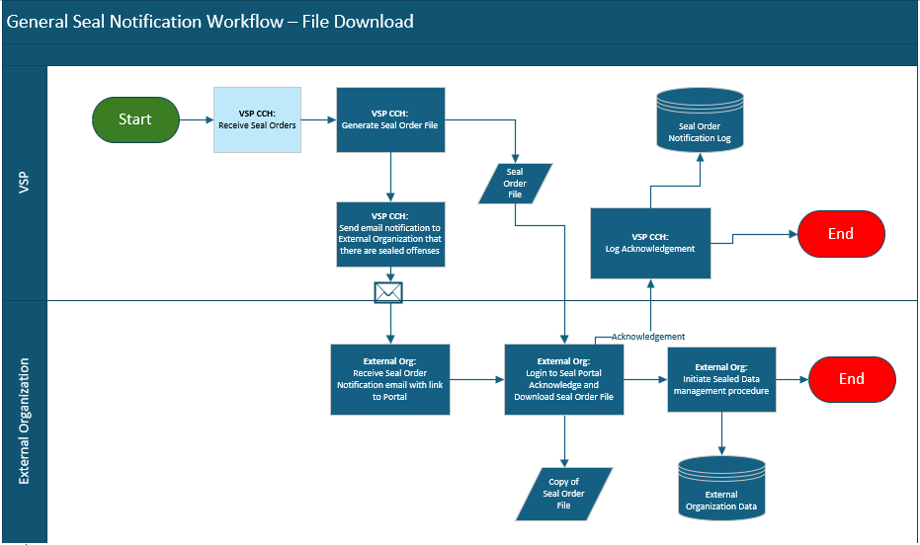

General Seal Notification Workflow:
- A seal order is received and processed.
- A file will be created daily for all seal orders process.
- An email notification is sent to each organization directing them to the Seal Order Notification Portal.
- External organization logs in to portal and downloads file.
- VSP will log the acknowledgement of the seal notification.
- External organization determines which seal orders they have and take necessary steps to seal the information.

1.3 Seal Order Notification Email

A file will be generated on a periodic basis (daily or weekly) that contains all seal orders that were received since the last run. An email will be sent to each registered account to notify them that there is a file ready for download. Below is a sample email:

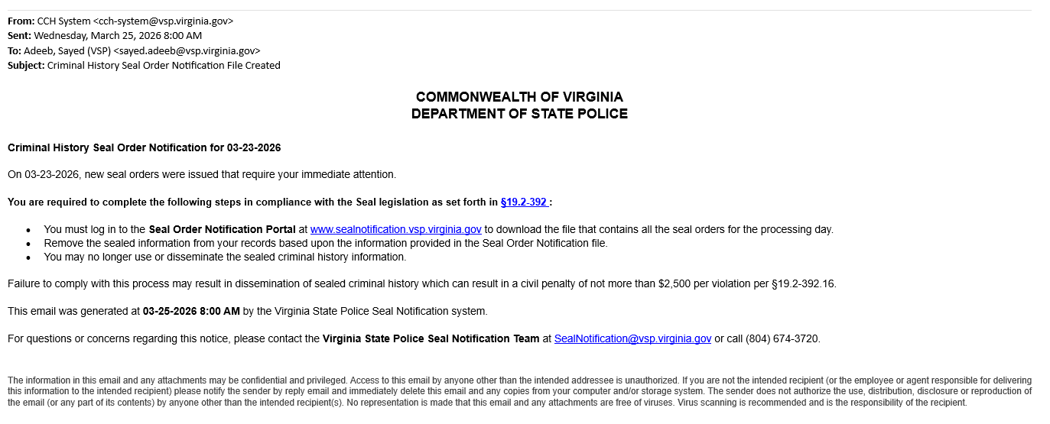
SAMPLE

1.4 Seal Order Notification Portal

A secure portal will be provided to facilitate the download of the Seal Order Notification file and provide acknowledgement that the company has received the seal order information. This will serve as acknowledgement that the company is taking the appropriate action to seal the information in their system.

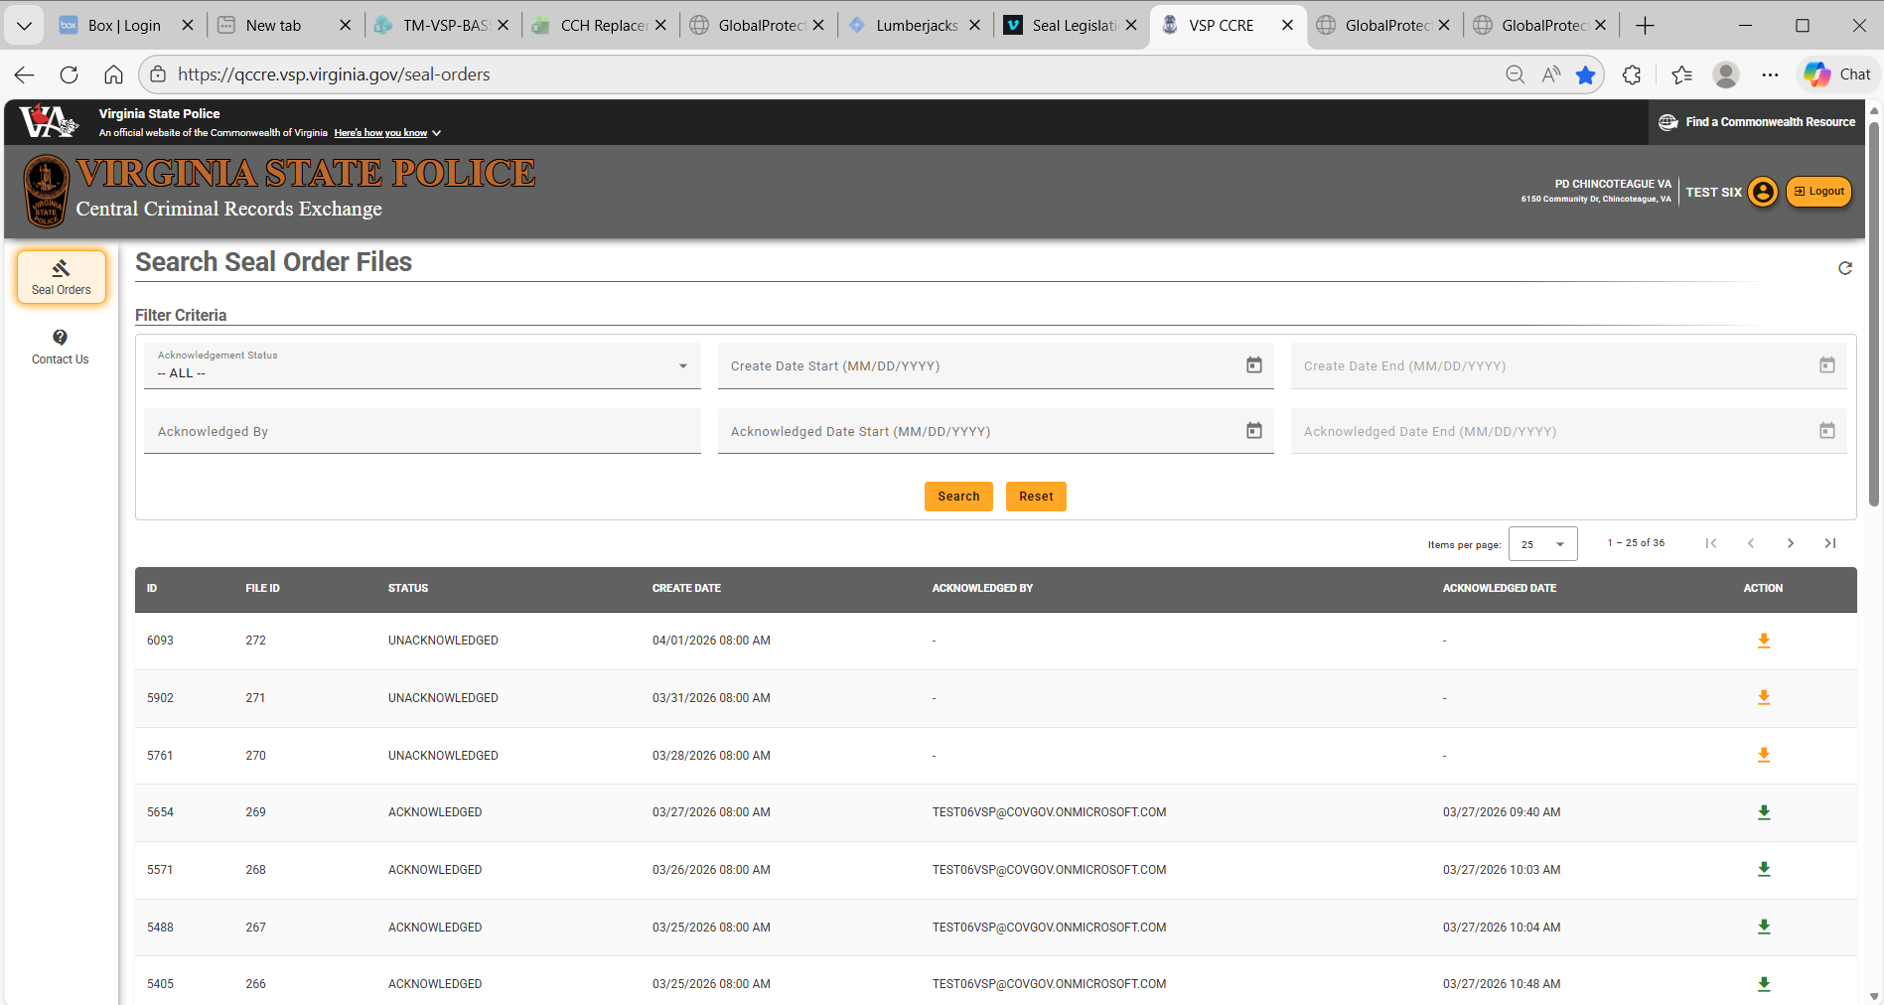
SAMPLE

2. File Specifications
This section presents the specifications for the information in the file. Per the Code of Virginia (COV), VSP must provide notifications to any entity that may have received criminal history information that is related to the seal orders. The seal notification file utilizes a single format used to provide seal order notification to all entities and is not customized for any entity.

2.1. File Format

The Seal Order Notification file will be a pipe delimited file. It will contain a record for each seal order. If an individual has 2 offenses sealed, there will be 2 records in the file.

2.2. File Definition

The following data elements are in the Seal Notifications file:

 |  |  | VSP to Interfacing System Seal Notification
 | Data Element | Data Type | Data Length | Format | Possible Values
Seal Order Information
 | Interfacing  System Seal  Notification  Batch ID | AN | 8 | XXXXXXXX
 | Seal Order ID | AN | 18
 | Order Type | A | 9 |  | This field is used to designate seal or unseal. Spaces will be padded on the end.  - “S” - Seal Notification (Seal notification communicates that this criminal history must be deleted and cannot be disseminated to anyone)  - “V” – Void Seal Notification (Void Seal indicates that the courts have determined that the seal or criminal history is no longer valid)
 | Order Legal Authority | A | 20 |  | The section of the Virginia Code that authorizes the sealing of the criminal history information
 | Court Case  Number | AN | 15 |  | Unique identifier assigned by the court for the case
 | Seal Order Date | D | 8 | YYYYMMDD
 | Disposition Code | AN | 4 |  | Abbreviation to summarize the outcome of the case. Ex: (G, D, DD, GA, etc.)
 | Disposition Description | AN | 20 |  | Short description of the disposition code. Ex: (Guilty, Dismissed, Deferred, Guilty in Absentia, etc.)
 | Disposition Date | D | 8 | YYYYMMDD | Date the case was decided
 | Disposing Court ORI | AN | 9 |  | Standard unique identifier for the court
 | Court FIPS | AN | 4 |  | Standard unique identifier of the court’s geographic location
 | Court Name | AN | 100 |  | Name of Court
Charge
 |  | VSP to Interfacing System Seal Notification
 | Data Element | Data Type | Data Length | Format | Possible Values
 | Offense  Tracking  Number | AN | 15 |  | Unique identifier of the offense
 | Document  Control  Number | AN | 7 |  | Unique identifier of charge document
 | Code Cite | AN | 20 |  | The charge identifier per the Code of Virginia
 | Option Code | AN | 1 |  | Variation identifier
 | Code Cite Desc | AN | 50 |  | Description of the code cite charge
 | Code Cite  Modifier  Code | AN | 1 |  | Modifies the designation of a felony charge (A – Attempted, C – Conspiracy, F – Felony)
 | Case Type | AN | 2 |  | Classification of charge (M – Misdemeanor, F – Felony)
 | Case Locality or State Indicator | A | 1 |  | S – State, L - Local
 | VCC | AN | 20 |  | Virginia Crime Code identifier
 | Original/Ame nded Charge | A | 15 |  | Original, Amended
Person
 | First Name | A | 50
 | Middle Name | A | 20
 | Last Name | A | 50
 | Name Suffix | A | 4
 | Date Of Birth | D | 8 | YYYYMMDD
 | Sex | A | 1
 | SID | AN | 10 |  | Virginia State Identification Number
 | SSN | AN | 9
 | Alias Name 1 | A | 30 |  | Free form name field. Any commas will be removed and replaced with spaces. There will only be one space between name elements.
 | Alias Name 2 | A | 30 |  | Free form name field. Any commas will be removed and replaced with spaces. There will only be one space between name elements.

DATA TYPE LEGEND

A= Alphabetical Characters; AN=Alphanumeric; N = Numeric; S = Special Characters; D = Date; M = Mandatory; O = Optional; C = Conditional

2.3. Import file into EXCEL
The Seal Order Notification file will be a pipe delimited file to support automatic ingestion into record management systems. In order to import into EXCEL, you must use the import function from the Data tab. The delimiter would be “|”.

