How to Request a Criminal History Record Through the Virginia State Police Portal for Transmission to Fairfax Circuit Court

Contents
Introduction 2
Before you begin 2
Step 1: Go to the Virginia State Police website 3
Step 2: Choose the correct form 3
Step 3: Enter your search information 4
Step 4: Complete petition information 6
Step 5: Enter contact information 6
Step 6: Review payment information 7
Step 7: Confirm your request 7
Step 8: Generate your form 8
Step 9: Save or print the generated form 9
Important reminders 9
What happens next 10

Introduction
This guide explains how a petitioner can use the Virginia State Police public portal to request a criminal history record search through the Central Criminal Records Exchange (CCRE) and have the results sent to Fairfax County Circuit Court.

Before you begin
Have the following information ready before starting your request:
- Your name and identifying information as it appear on your seal or expunge petition
- Your petition type and the purpose for requesting the criminal history record (e.g., seal, expunge, etc.)
- The circuit court where your petition was filed.
- Your civil case number exactly as it appears on your petition.
- Your email address and phone number.
- Your Social Security number.
The portal will show a red asterisk next to fields that are required, and you must complete all required fields before you can continue.

Step 1: Go to the Virginia State Police website
Open your web browser and go to www.vsp.virginia.gov. From the home page, select Services, then choose Criminal Record Check.
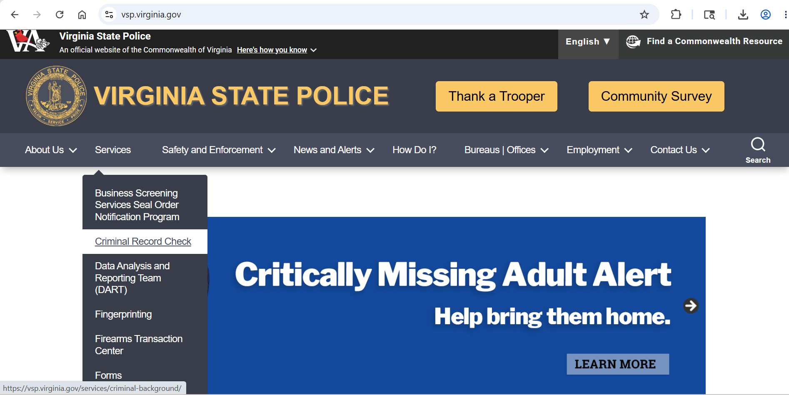

Step 2: Choose the correct form
On the public portal page, locate the Form dropdown. Select SP-356 Criminal History Name Search for Seal and Expunge Petitions.
Once this form is selected, the page will display the fields needed for petition-based requests.
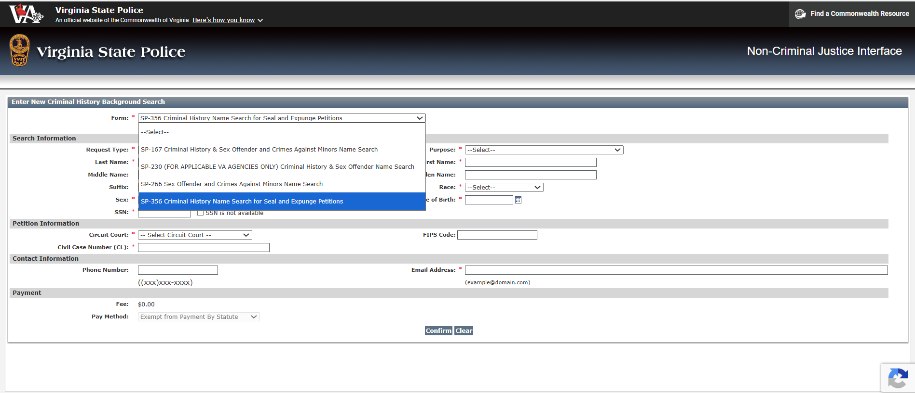

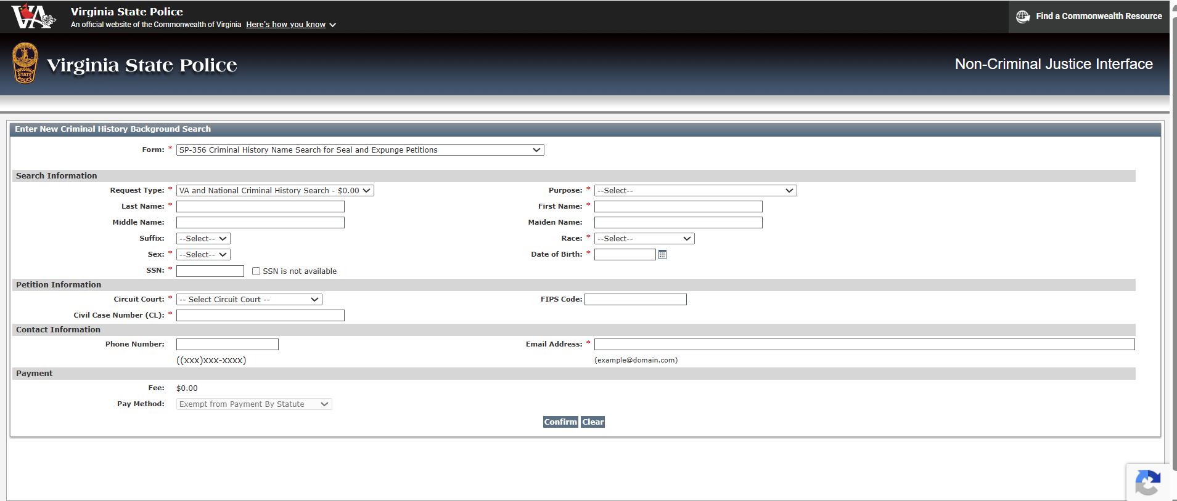

Step 3: Enter your search information
Complete the Search Information section by entering the required personal details, such as your last name, first name, sex, race, and date of birth.
In the Purpose dropdown, choose the option that matches your petition:
- Seal Petition - 19.2-392.12
- Seal Petition Subsidiary - 19.2-392.12:1
- Expungement - Non-Conviction - 19.2-392.2

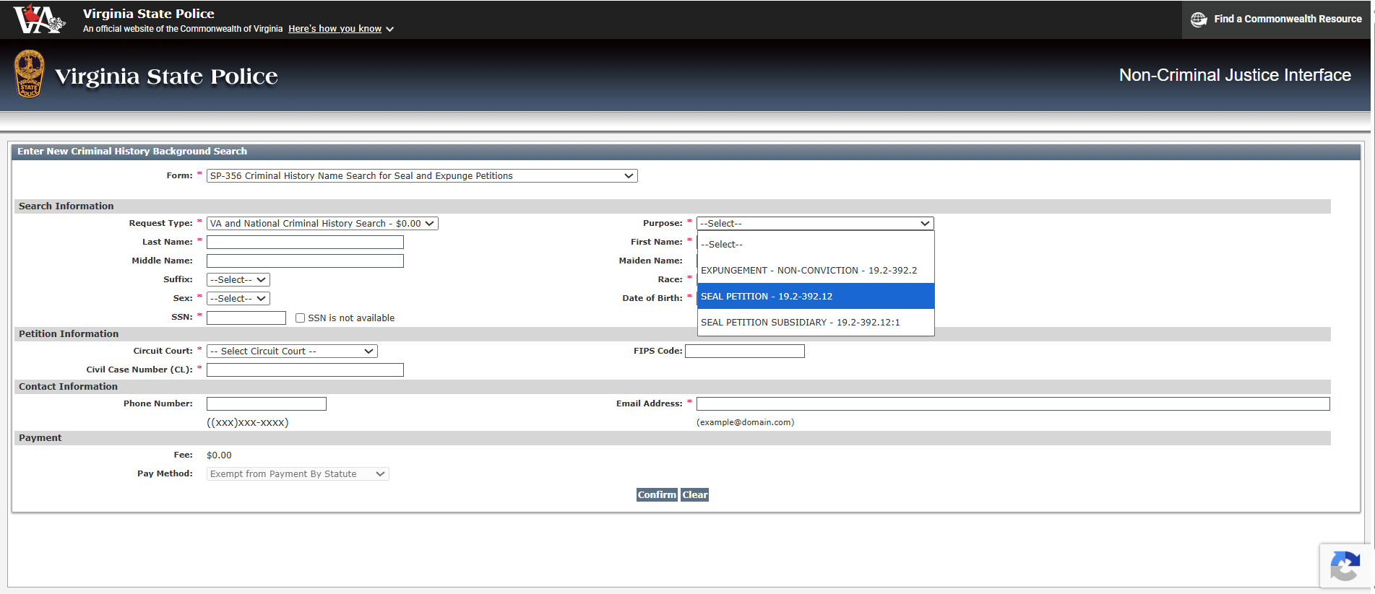
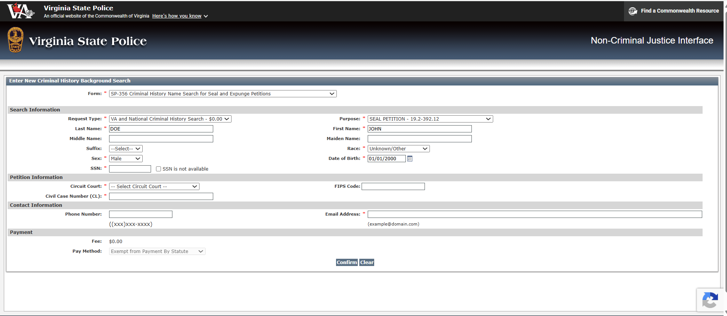
For the SSN field:
- Enter your Social Security number if it is available. Failure to provide SSN may result in an inability to process this request due to multiple records with similar names and demographics. The social security number provided will be used solely for the purpose of conducting the criminal history record search and for no other purpose. Without this additional identifier, there may be processing delays, and the petitioner will be required to submit a set of fingerprints along with this request form for CCRE to forward the correct criminal record to the petition filing circuit court. Numbers provided will be used to help identify the proper record and will be used for no other purpose.
- If you do not have an SSN or it is truly unavailable, check the SSN is not available box.
When the checkbox is selected, the portal displays a message reminding you that providing an SSN improves match accuracy and that the box should be checked only if the person does not have an SSN or it is truly unavailable.

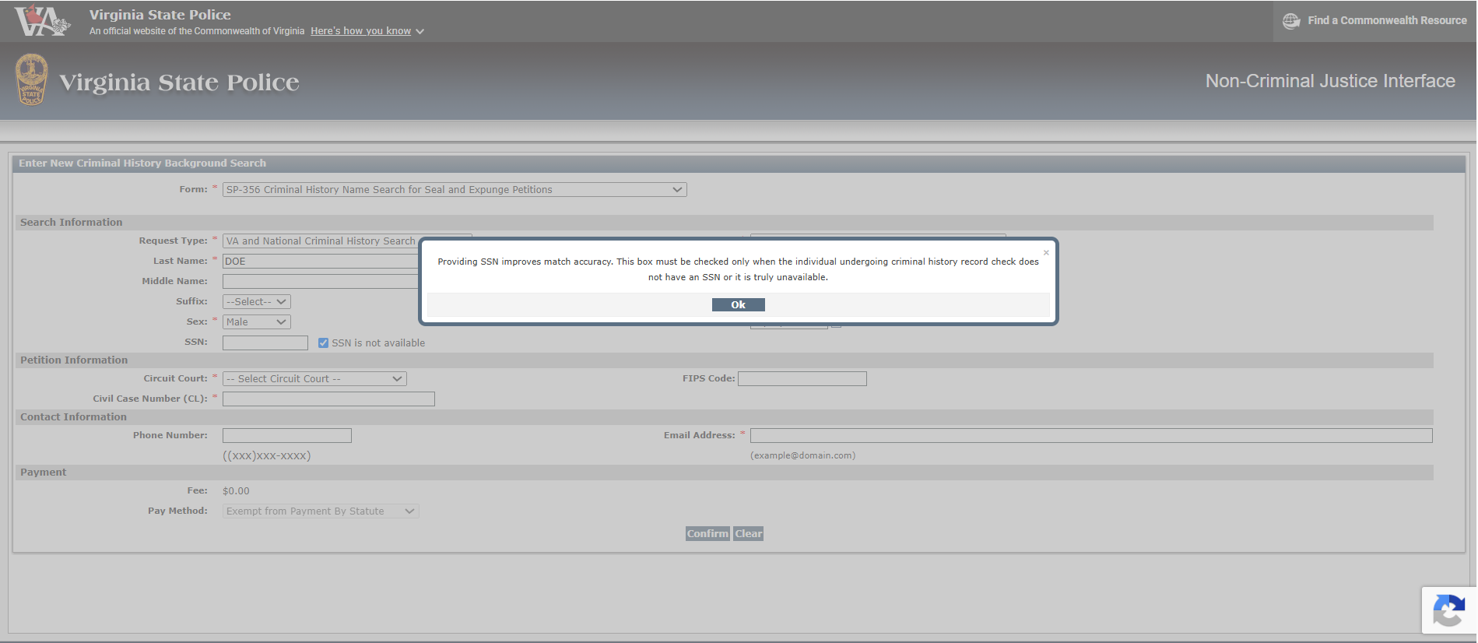

Step 4: Complete petition information
In the Circuit Court dropdown, select Fairfax County Circuit Court.
After you choose the court, the FIPS Code field will automatically populate.
Next, enter your Civil Case Number (CL) exactly as it appears on your petition. For Fairfax, the required format is:
CL-YYYY-#######
Example: CL-2026-1234567.
The civil case number must match the number on your petition. If the value does not follow the correct Fairfax format, the portal will display an error message telling you that the Civil Case Number is invalid and reminding you to ensure that it matches the number on your petition.
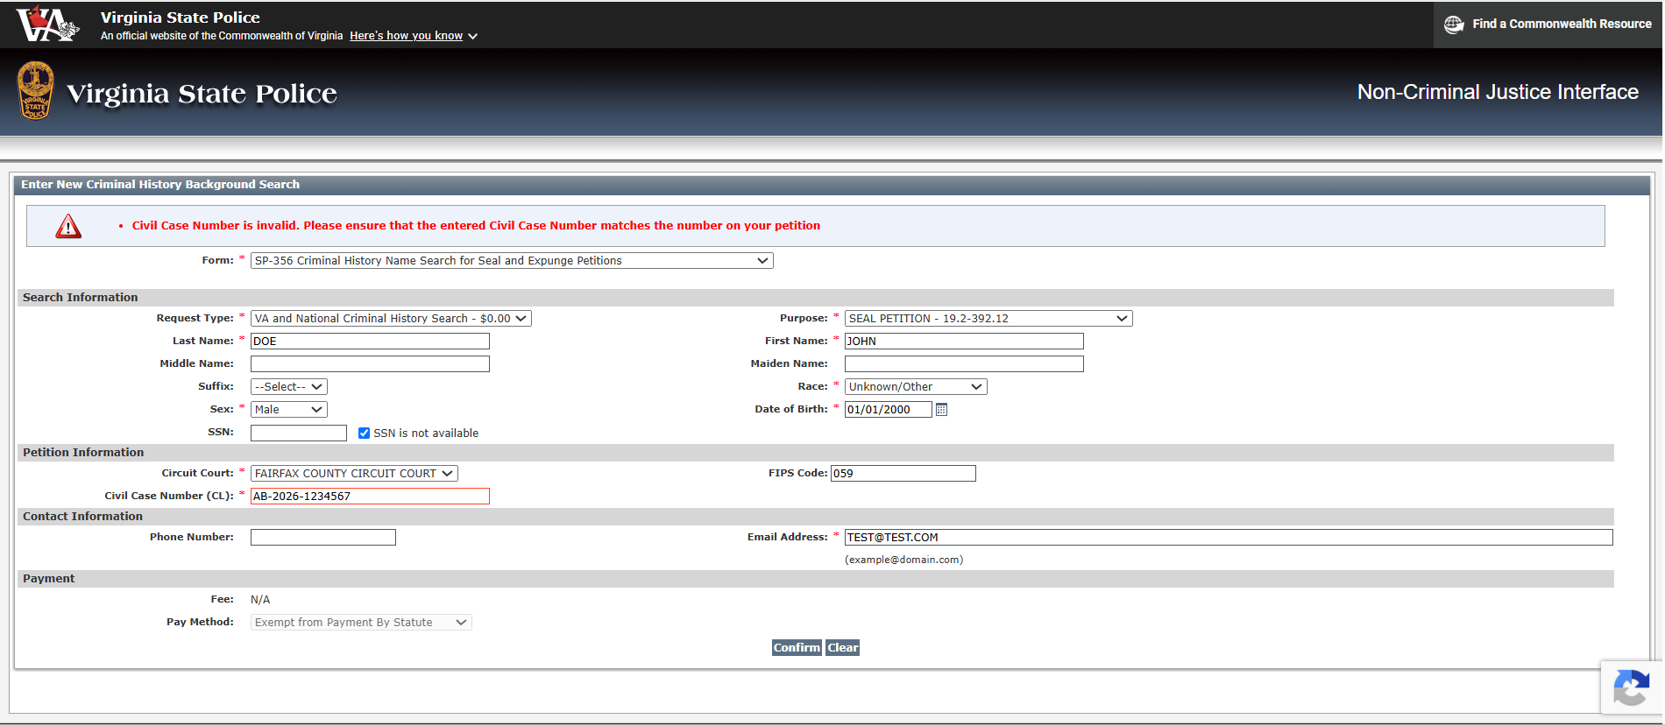

Step 5: Enter contact information
Complete the Contact Information section, including your phone number and email address.
Your email address is required. If you try to continue without entering it, the system will display an error message at the top of the page indicating that the email address is required.

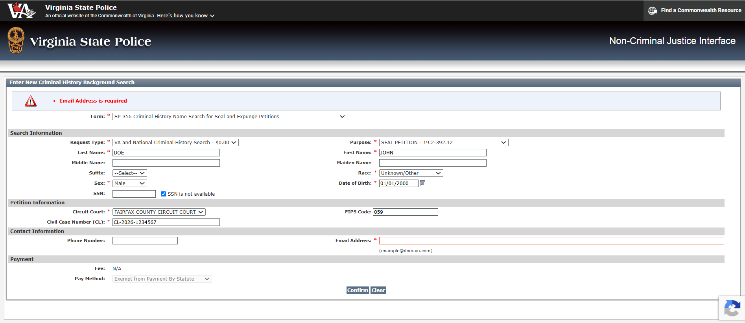

Step 6: Review payment information
For seal and expunge petition requests, the payment section is automatically set to $0.00 and the payment method is shown as Exempt from Payment By Statute.
This means you do not need to submit payment through the portal for this type of request.

Step 7: Confirm your request
After entering all required information, click Confirm.
The portal will take you to a confirmation screen that displays the information you entered, including your selected form, request type, petition purpose, Fairfax Circuit Court, civil case number, and contact information.
Carefully review this screen before moving forward. If you need to make corrections, select Cancel and return to the previous screen.

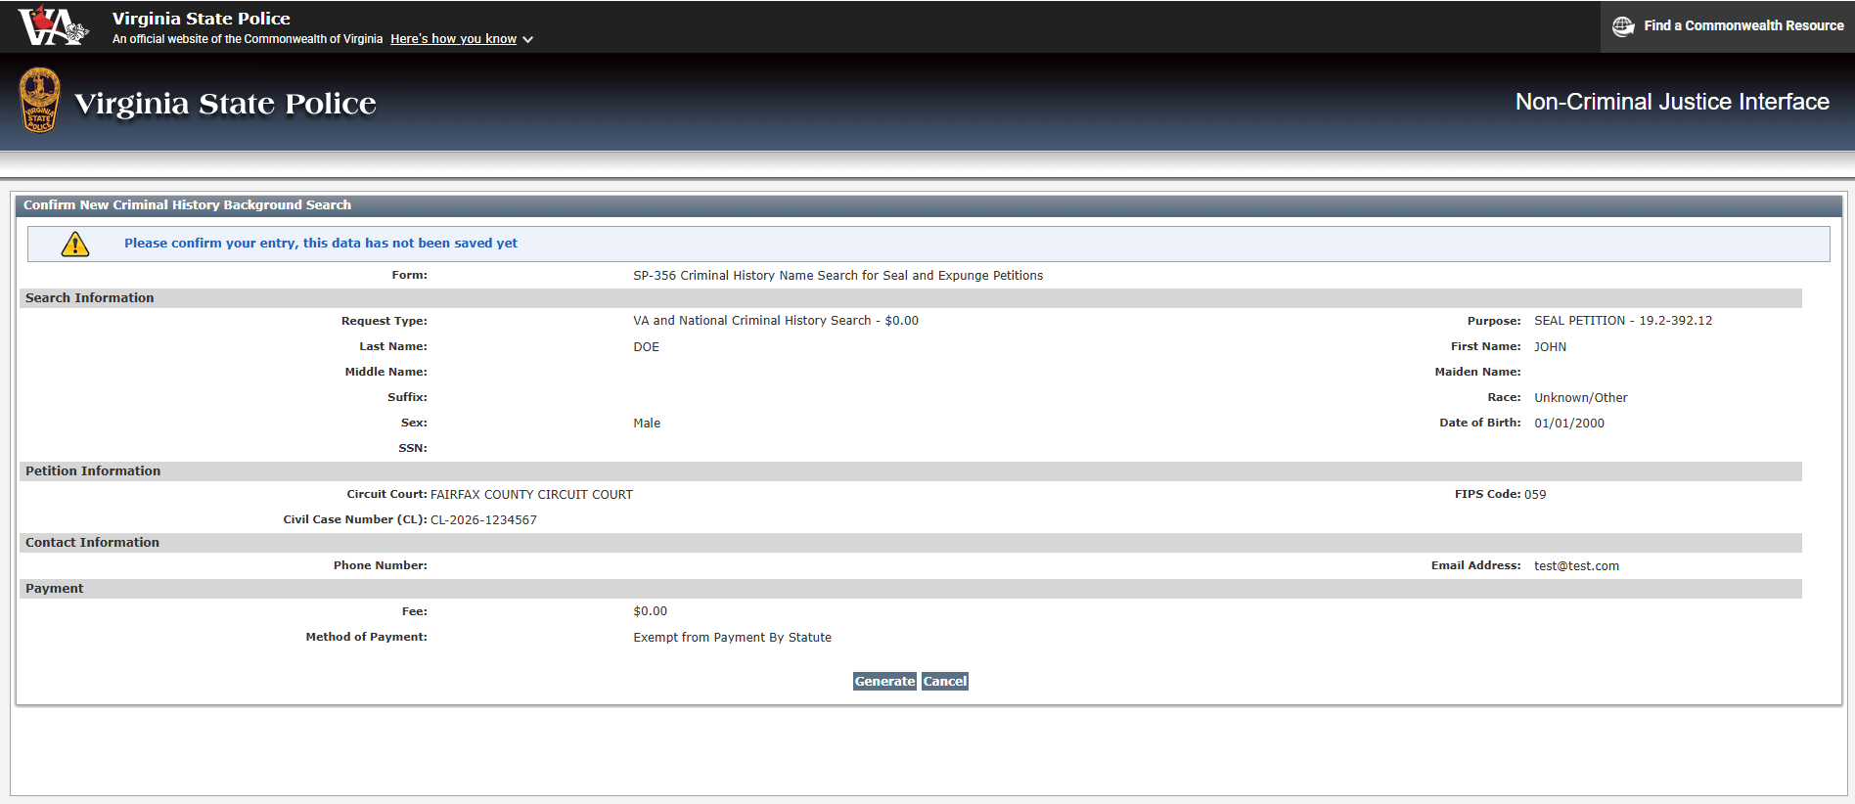

Step 8: Generate your form
If all information is correct, click Generate on the confirmation page.
The portal will then display a message stating that the form was created successfully and instructing you to print a copy for your records and click OK to view the form.

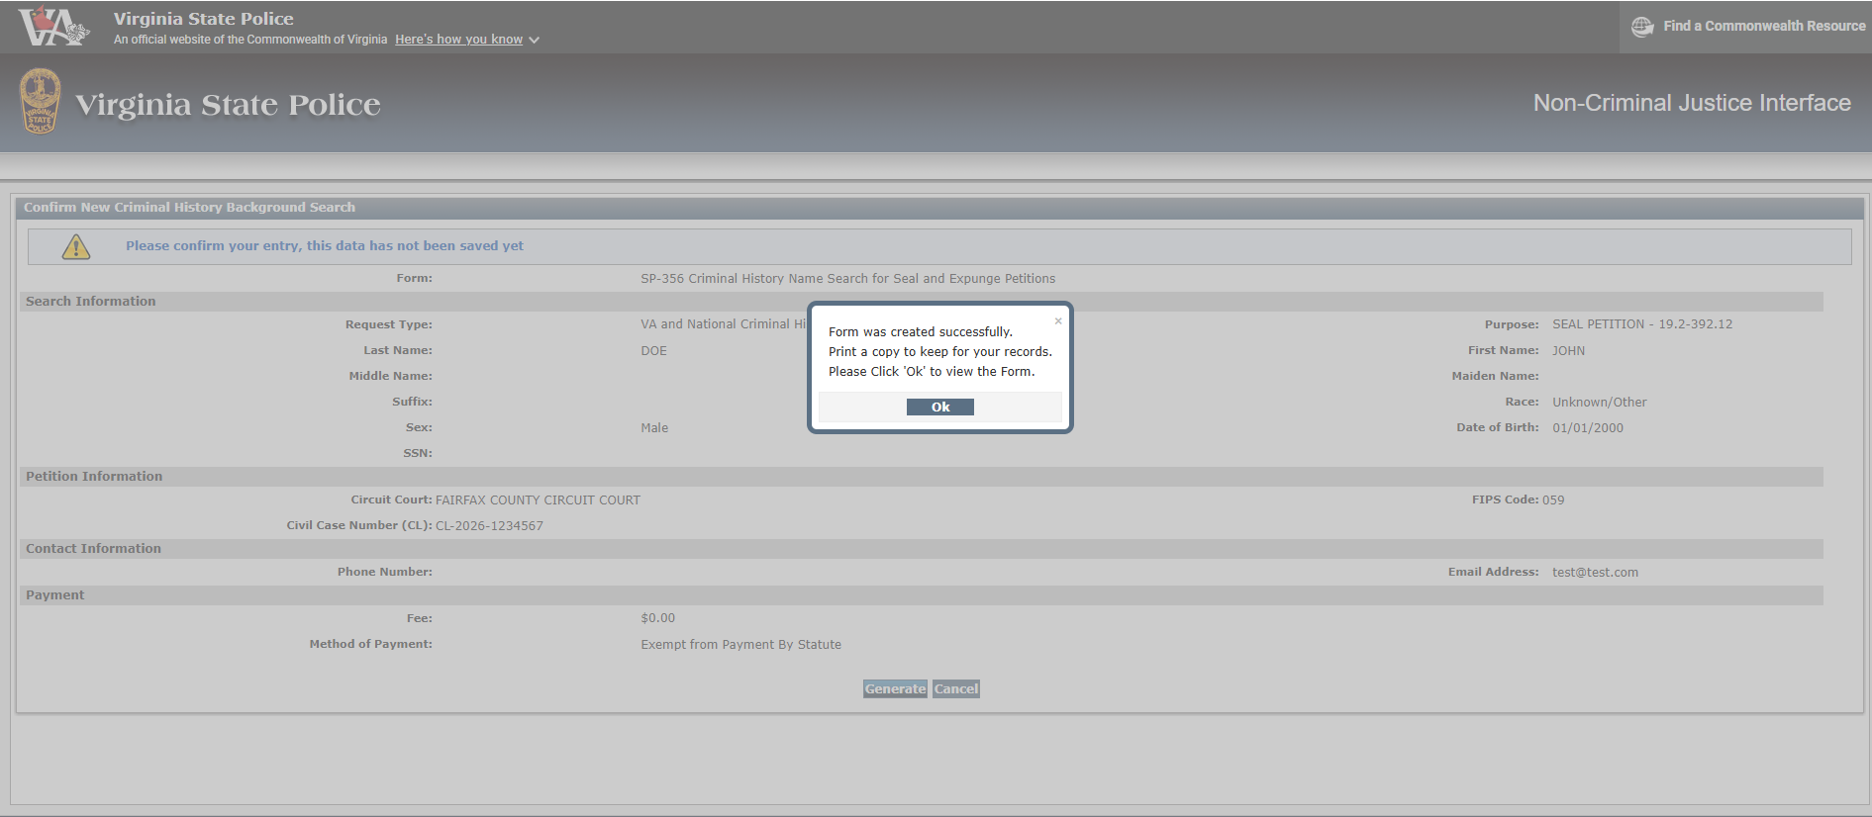

Step 9: Save or print the generated form
After the form is generated, it will open as a downloadable document that you can save to your computer or print for your records.
The generated form includes a unique Transaction Control Number near the top right of the document. Keep this number for future correspondence with Virginia State Police, because it helps VSP identify your request if you need to ask questions later.

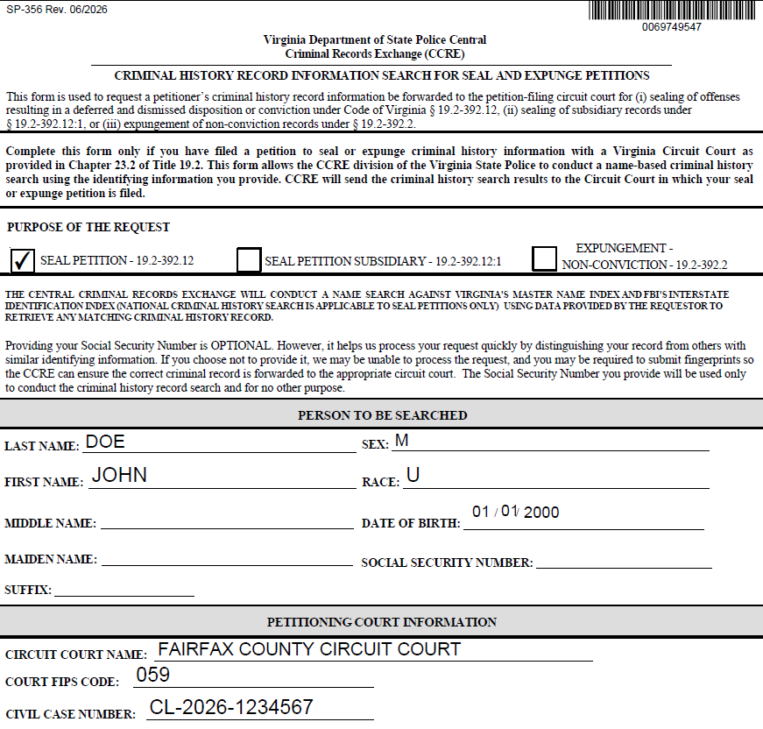

Important reminders
- Enter all required fields marked with a red asterisk before clicking Confirm.
- Enter your first name, last name, middle name & suffix (if provided to the court during petition filing) exactly as they appear on your petition to avoid validation errors.
- Make sure the Fairfax civil case number matches your petition exactly.
- Check SSN is not available only if no SSN exists or it is truly unavailable.
- Save or print the generated form for your records.
- Keep your Transaction Control Number handy when contacting CCRE with any questions regarding your criminal history record request.

What happens next
Once submitted, the request is used by CCRE to conduct the Virginia and national name-based criminal history search associated with your petition, and the resulting criminal history record is intended to be forwarded to the circuit court identified in your request.

