Training – Seal Order Notification Portal & Download File

VSP - BASS
Process Improvement Engineering Section
Document Owner: | Jennifer Glass | Title: | PIES Manager
Document Manager: | Jennifer Glass | Title: | PIES Manager
Accountable Executive: | Major Matthew T. Patterson | Title: | Deputy BASS Director
Version: | #1.0 | Effective Date: | 7/1/2026

Background:
File Download Notifications – organizations are notified of ALL seal orders processed for the entire Commonwealth. A pipe delimited file can be downloaded to view all seal orders processed and the organization must determine which seal orders are relevant to them. Downloading the file constitutes acknowledgement of the seal orders.

Process Overview
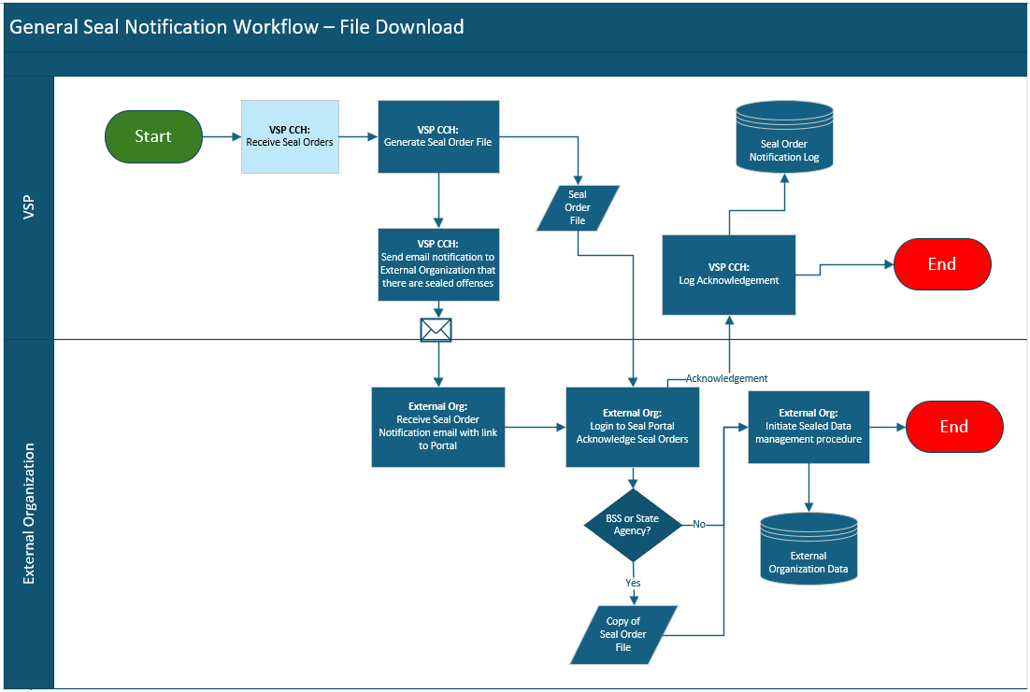

- VSP CCH System receives Seal Orders
- VSP CCH System generates a Seal Order File
- VSP CCH System sends an email notification to external organizations that there are sealed offenses.
- The external organization receives the notification email with a link to the VSP Seal Order Notification Portal
- The external organization logs into the VSP Seal Order Notification Portal:
  - Downloads the Seal Order File
  - Downloading filre will acknowledge the receipt of the seal orders
  - Continues with internal processes for managing seal order notifications
- VSP CCH System receives the acknowledgement of the notification.
- Acknowledgement is stored in the Seal Order Notification Log

Email
An email notification is sent each day a download file is generated:

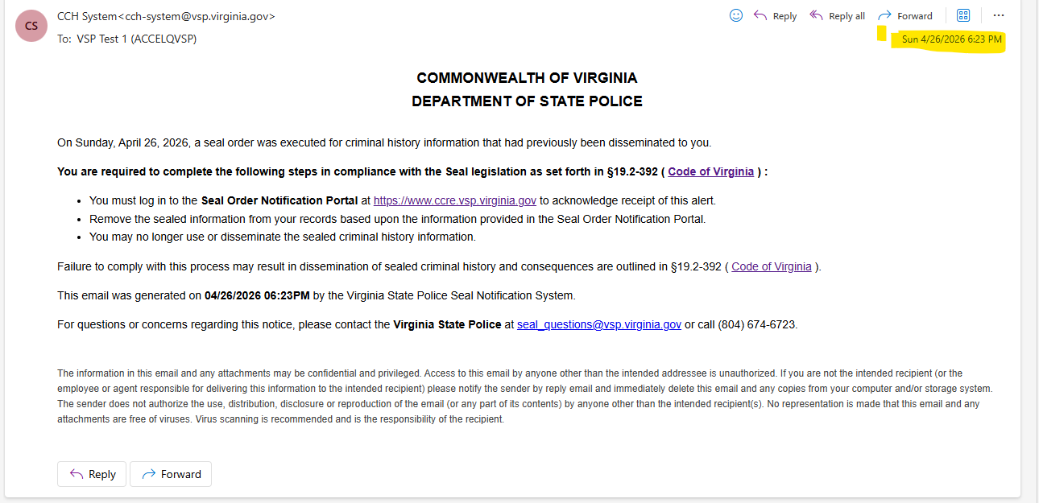

Step 1 – The user can click on the URL in the email to access the Seal Order Notification Portal:
https://ccre.vsp.virginia.gov/
The user will be directed to the appropriate Seal Order Notification page based upon their roles defined during their OKTA setup. State Agencies will be directed to the File Download page.

Step 2 – Login using your email and password provided through the OKTA setup. Complete authentication using OKTA verification process.

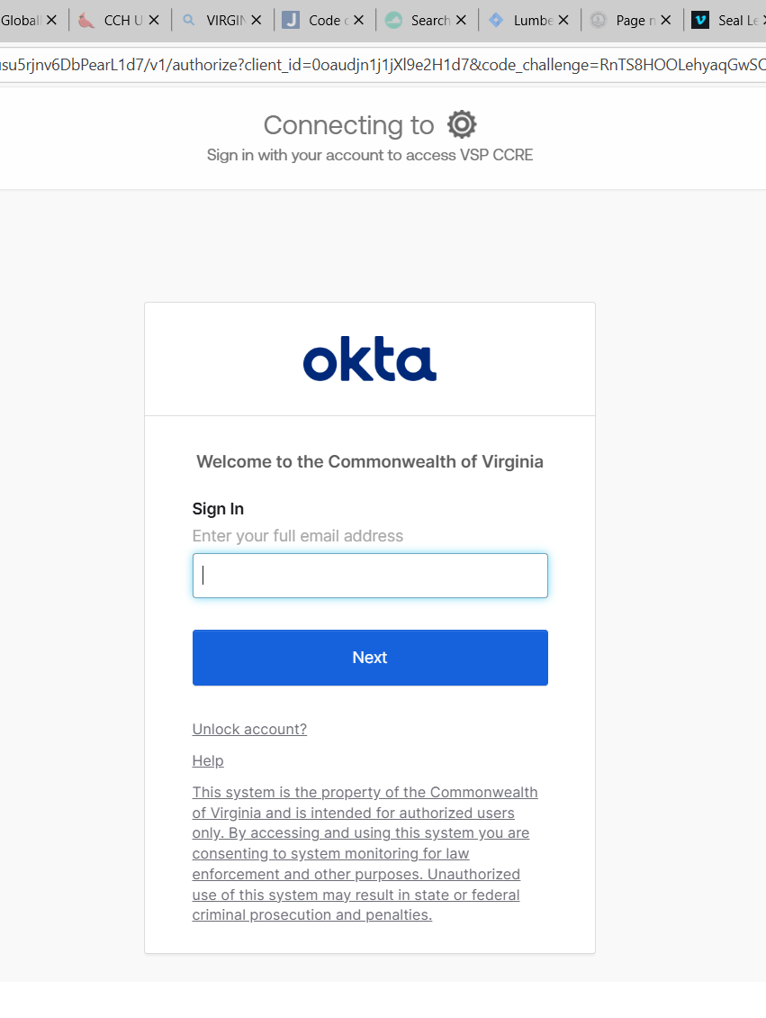

File Download Seal Order Notification Portal

Home Page Elements

Banner
- Title
- Organization Name & Address
- User ID
- Logout Button

Left Navigation Panels
- Seal Orders
- FOIA
- Contact Us

Main Body
- Search Filter options
- Search results
Note: Default filter is to show Unacknowledged Seal Order Notifications
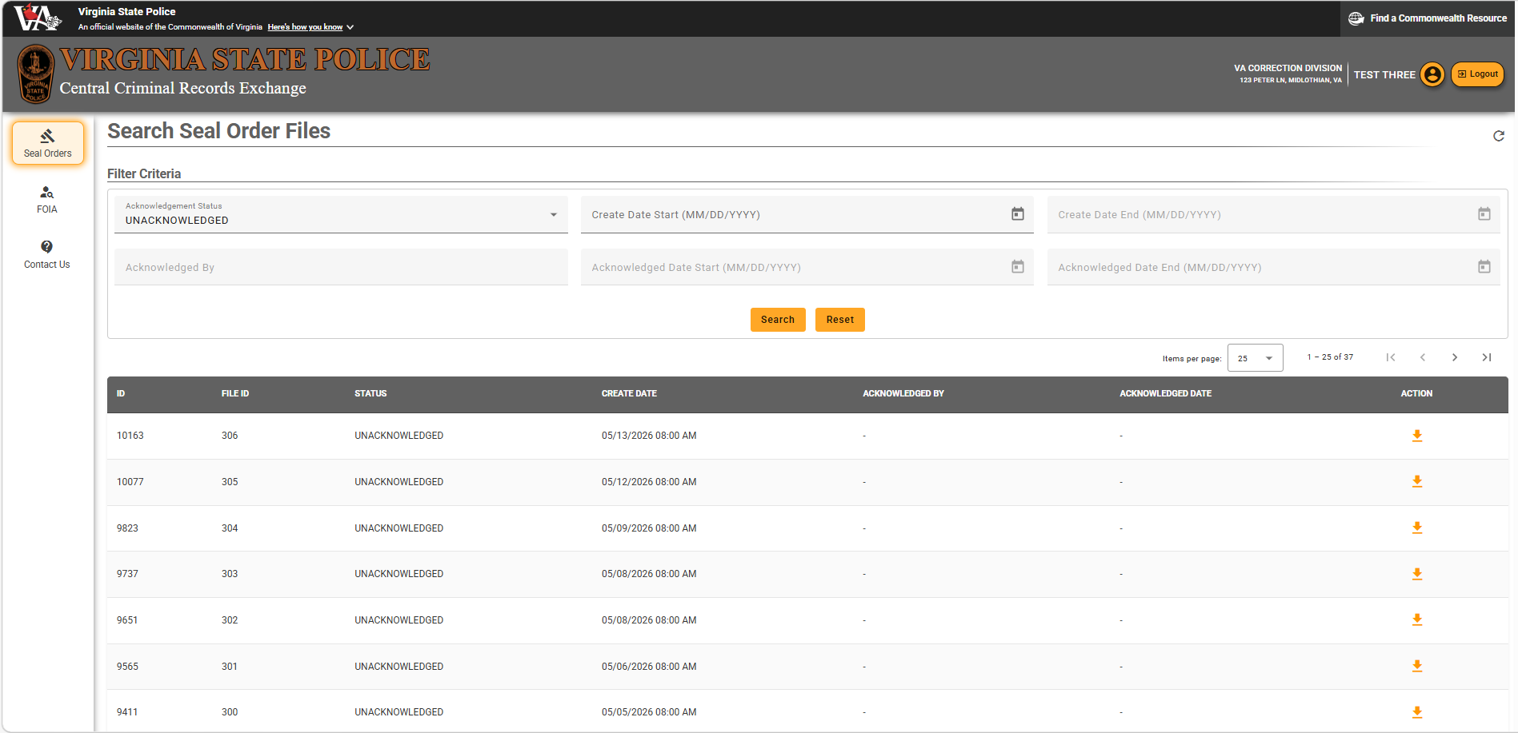

Search Seal Order Files

Step 1 – Enter filter criteria
Can enter any combination of filter criteria
- Acknowledgement Status – Dropdown (All, Acknowledged, Unacknowledged)
- Create Start Date and End Date – date seal order notification created
- Acknowledged by – user id who acknowledged seal order notification
- Acknowledged Start Date and End Date – date seal order notification acknowledged

Step 2 – Click on Search
*Note – Clicking on Reset button will return to the default search of all unacknowledged seal order notifications
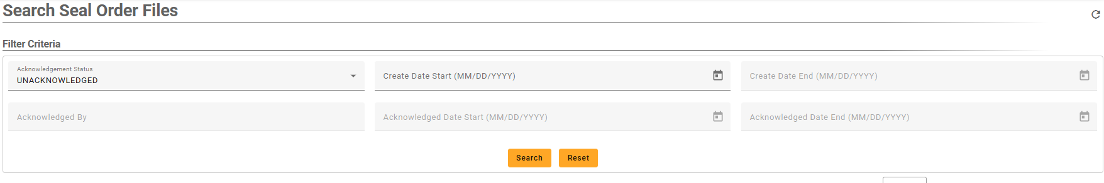
Search results will be displayed

Download Seal Order File

Step 1 – Select Download Icon

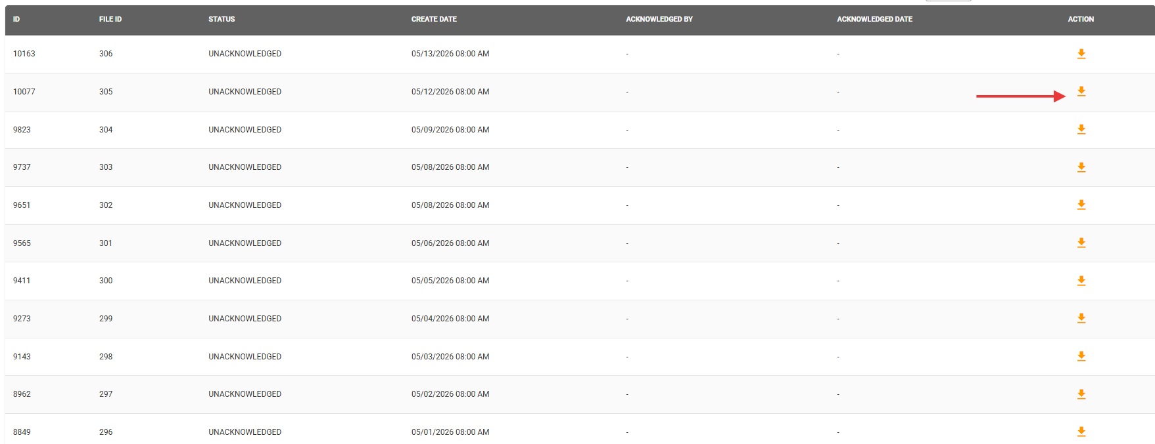

Step 2 – Select Yes to confirm download and acknowledge receipt of seal orders
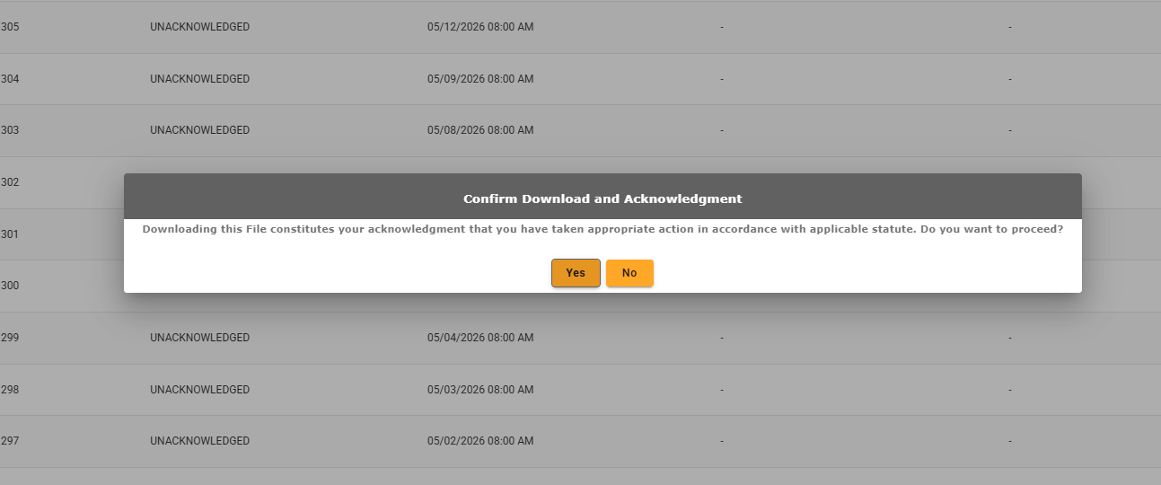
Seal Order Download file will be downloaded to PC
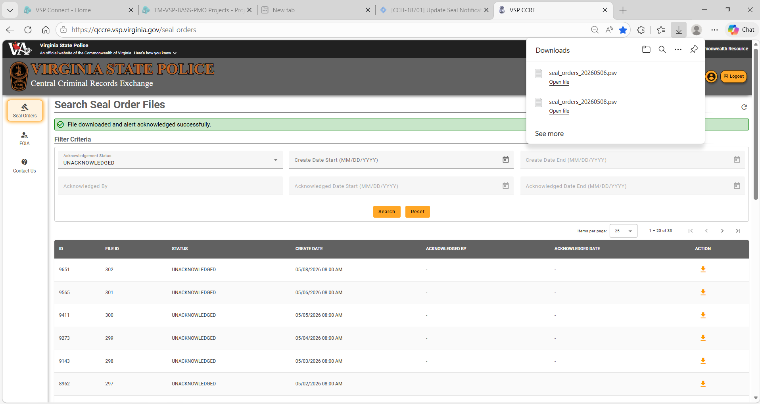

Step 4 – View Acknowledged Download Files
Selects Acknowledgement Status of ACKNOWLEDGED and click Search
Green Download Action icon indicates seal order file has been acknowledged
Acknowledged By and Acknowledgement Date should be displayed
** NOTE: You can download a previously acknowledged seal order file, it will not change the acknowledgement information.
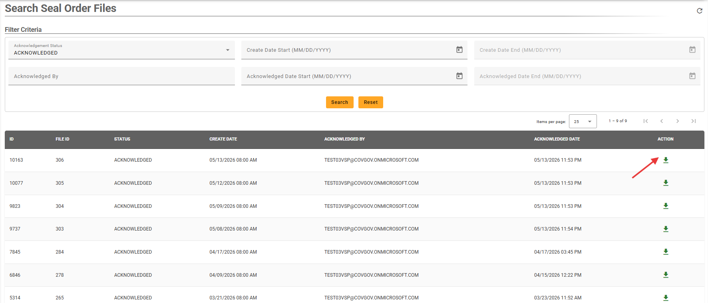

Open Seal Order File using Excel
The download file is a .psv (pipe separated values) file. This delimiter is commonly used when there may be other special characters in the file such as commas, periods, etc.
To open the file in Excel, you need to use the data import feature of Excel.

Step 1 – Open a blank worksheet in Excel
Step 2: Click on the Data tab
Step 3: Select “From Text/CSV”

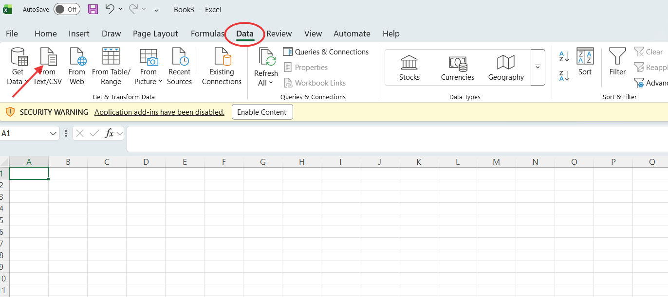

A dialog box will display.

Step 4 – Click on the drop down where it says Text Files and change it to All Files.
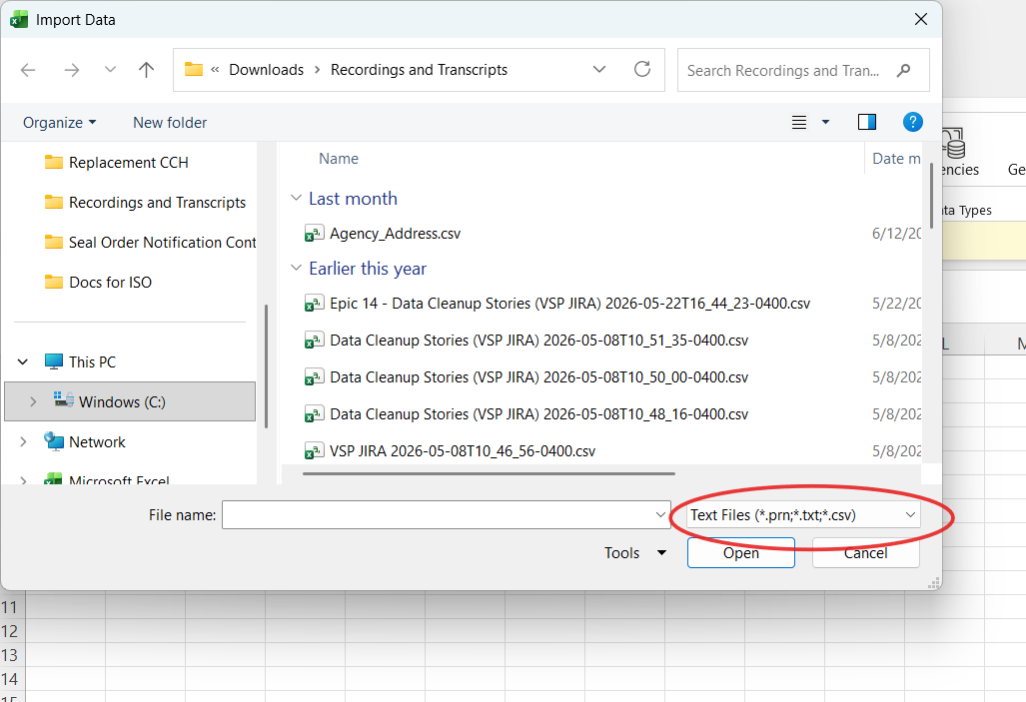

Step 5 – Select your file
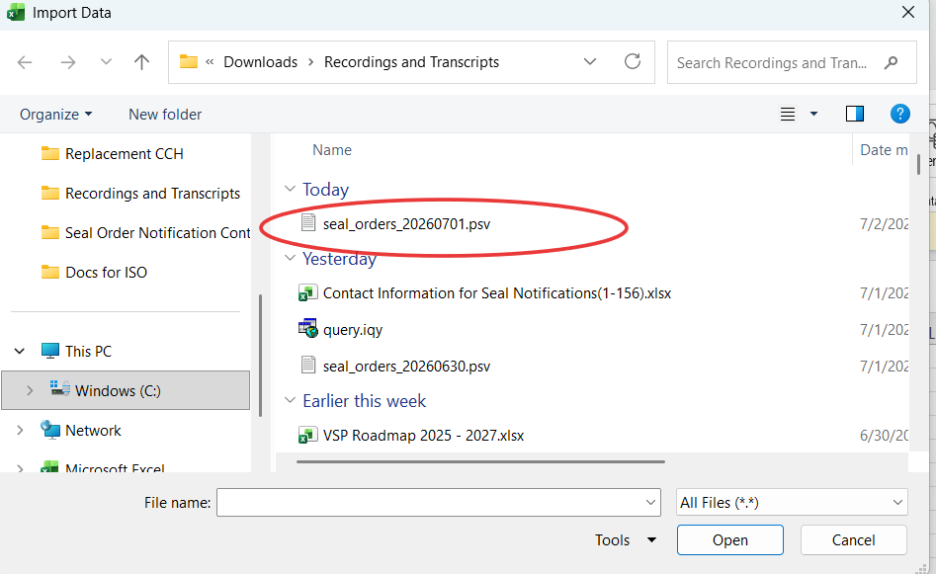

Step 6 – Click on Import
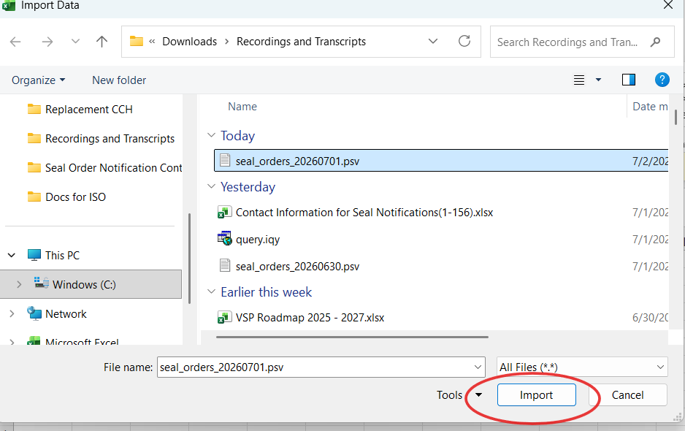

The file import dialog box will display

Step 7 – Click on Load button

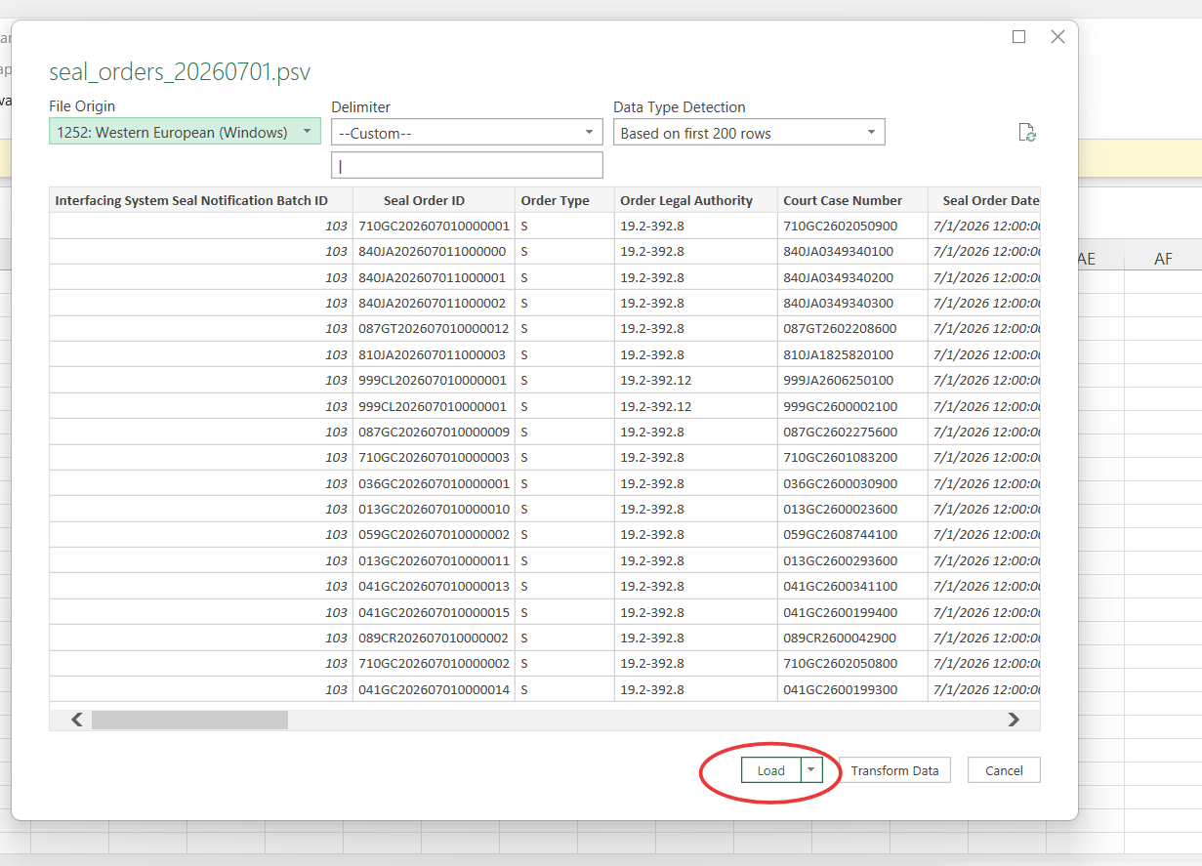

The data will be loaded into Excel for your review.
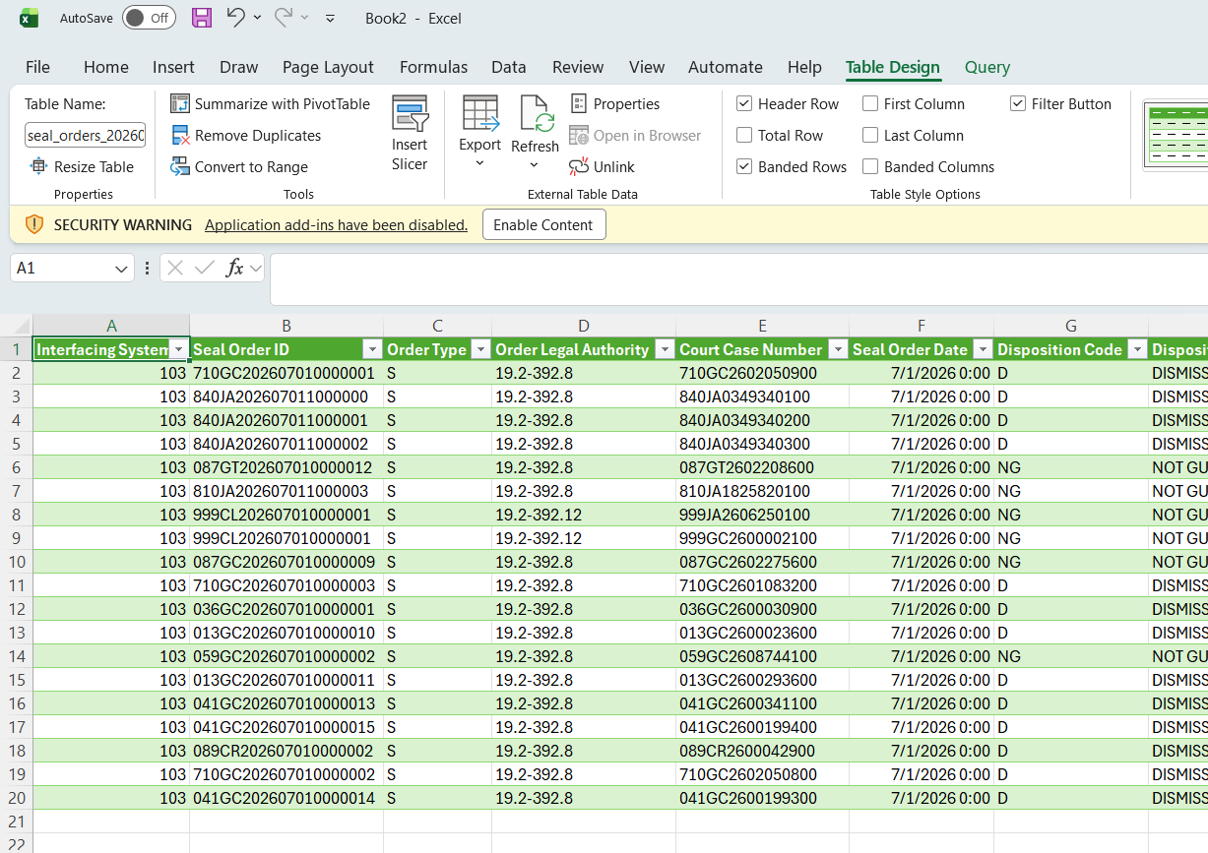

Revision History
Revision | Date | Created and Revised By | Approved By | Change Summary
0.1 | 05/12/2026 | Jennifer Glass |  | Initial version
0.5 | 05/13/2026 | Jennifer Glass |  | Continue Refinement
1.0 | 7/1/2026 | Susie Langston |  | Made specific to file download and added how to open psv in Excel

